Process ETL – Step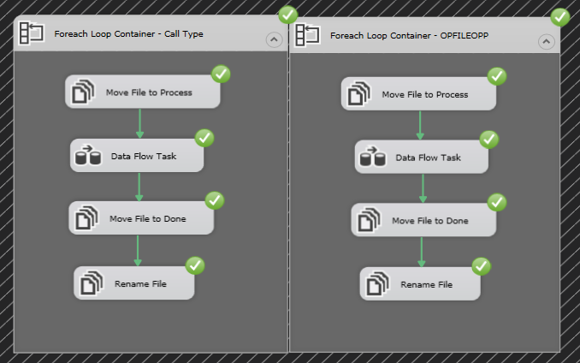 Dynamically upload CSV files:

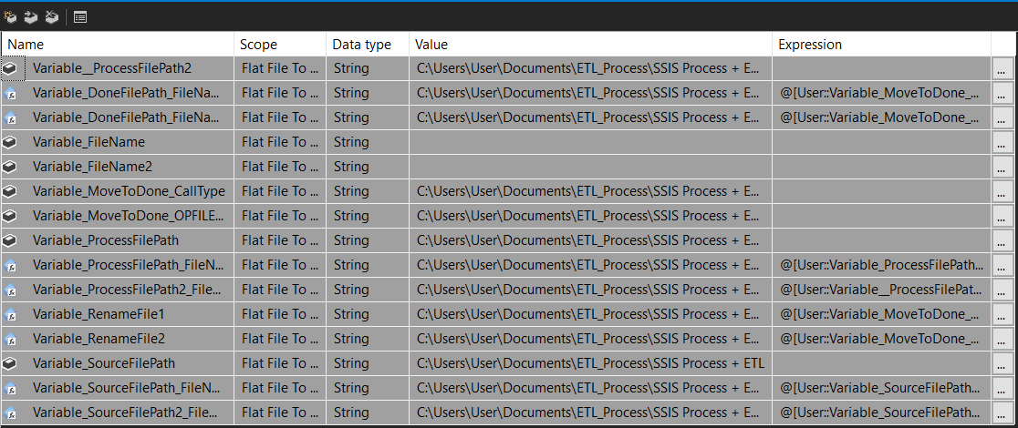Process ETL – The Variables of process Dynamically upload:

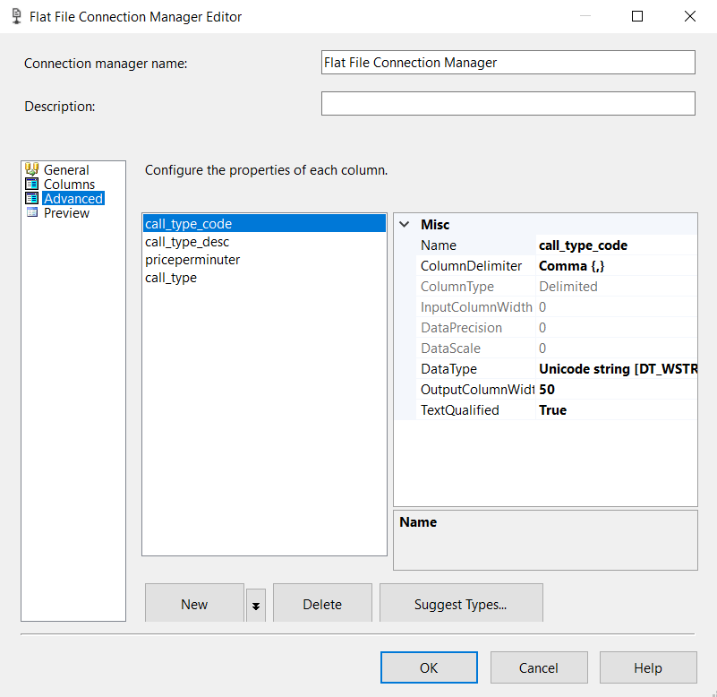

In editing of data in Connection Manager

We are change DataType of the data.

For the charging process to work.

Process ETL – The Result

Upload CSV files:

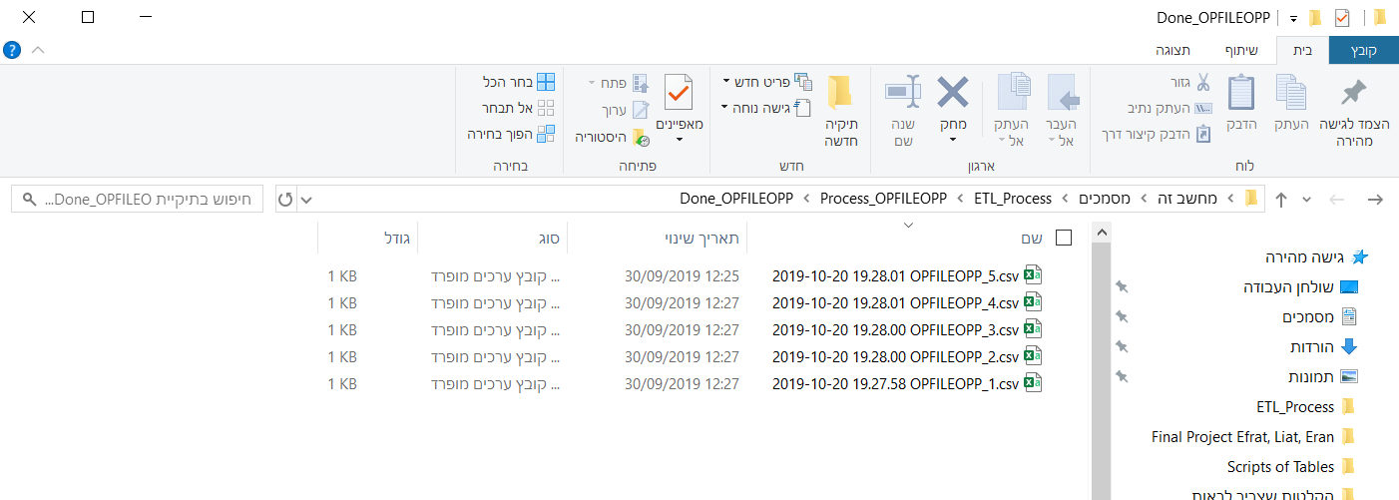OPFILEOPP

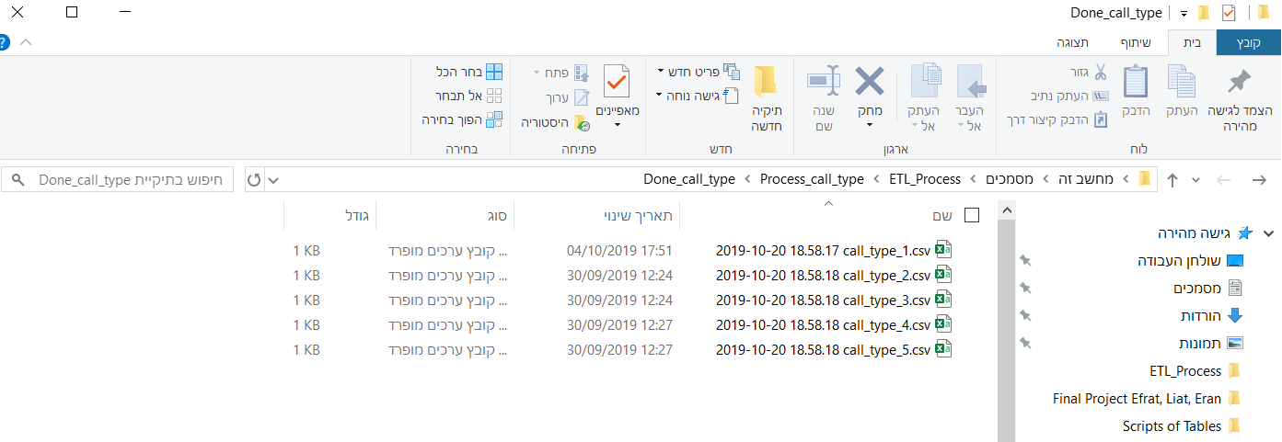Call_Type

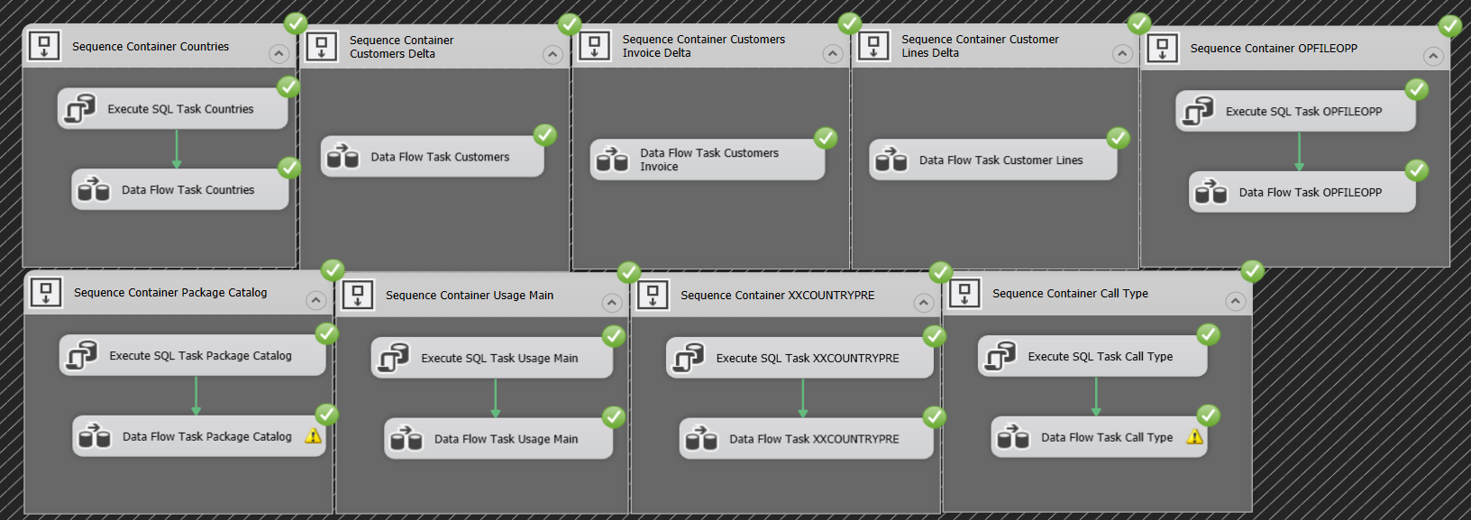Process ETL – Step Operation to Mirror:

Process ETL – Transfer only Delta of data - For example we show the Customers Table:

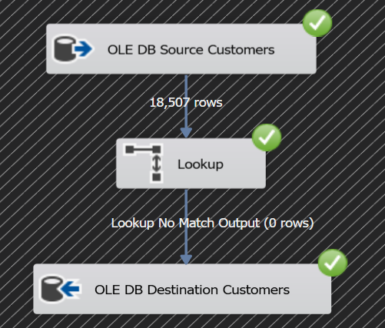

Uploading Excel to SSMS: Table Region Prefix:

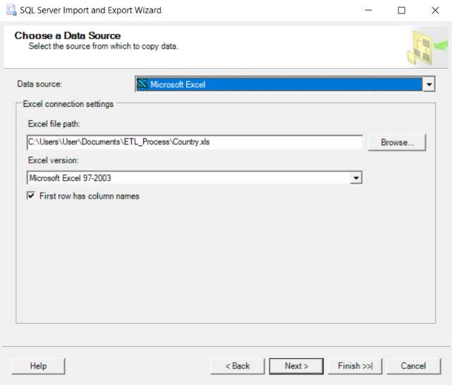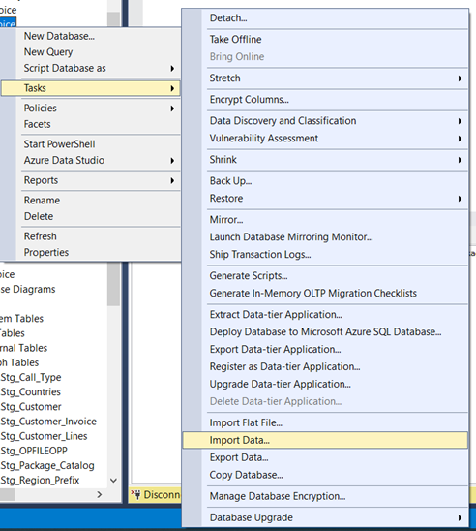1. 2.

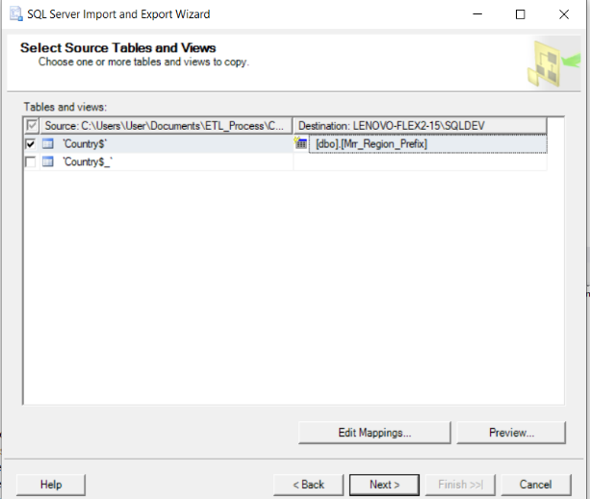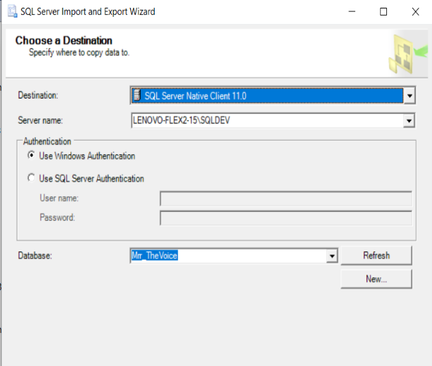3. 4.

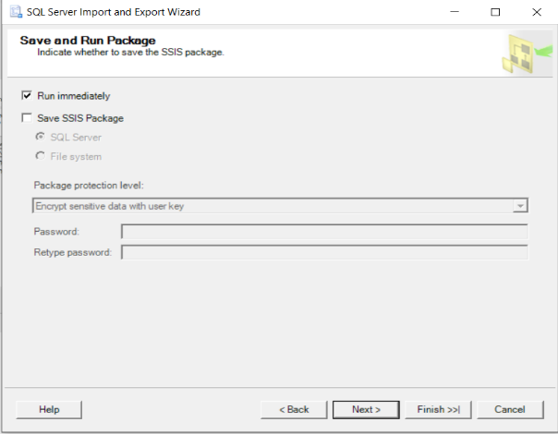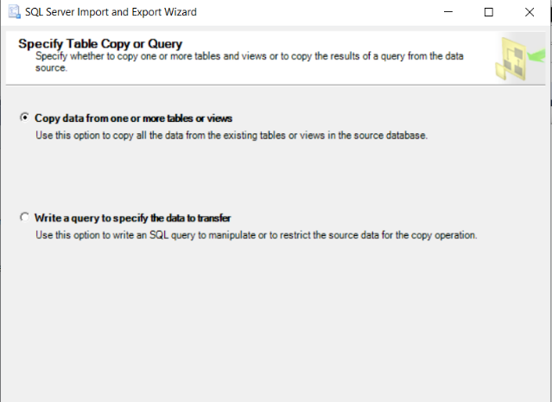5. 6.

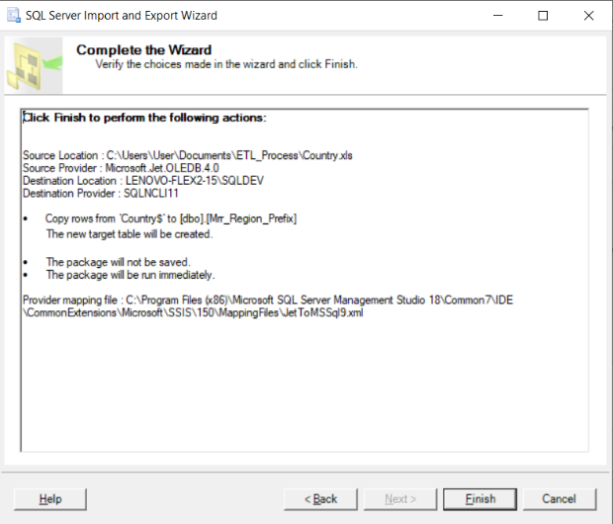7.

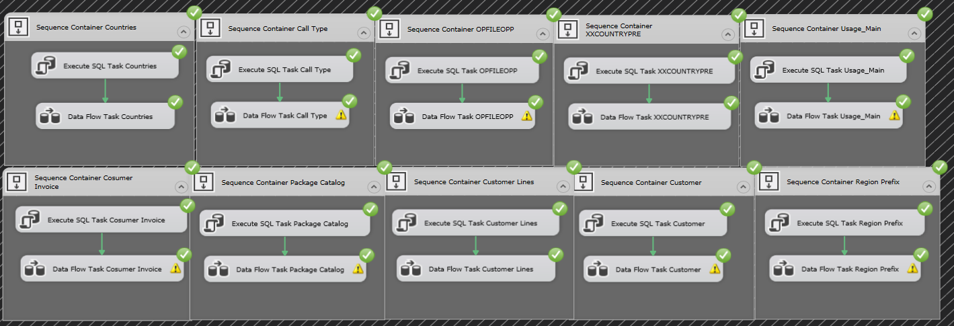Process ETL – Step Mirror to Stage:

Process ETL – Table errors handling – For example we show the Usage Main Table:

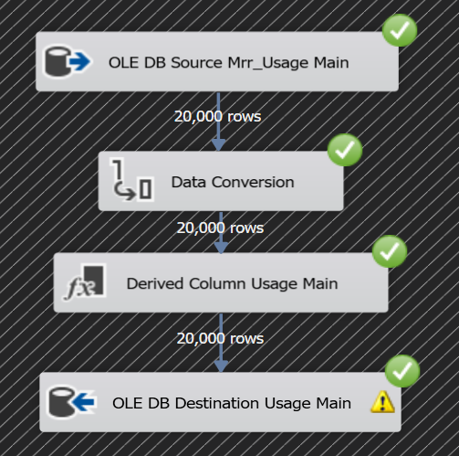

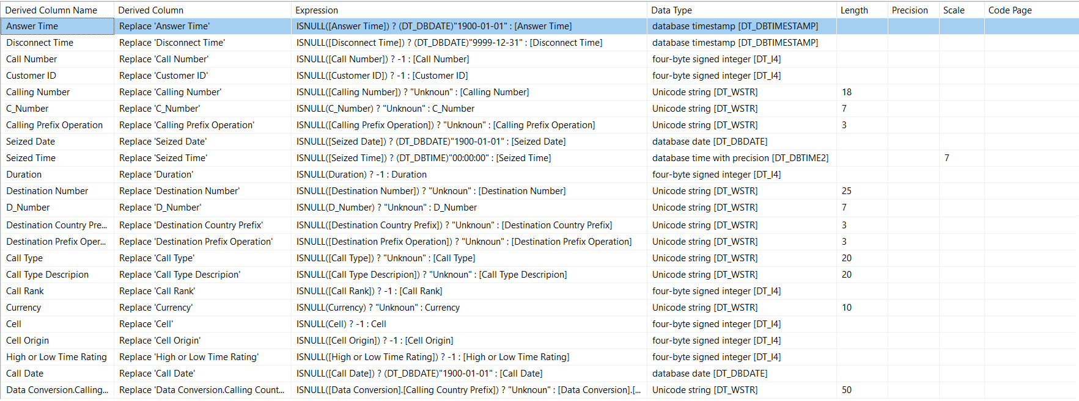Derived Column - Usage Main Table:

Scripts of Process Mirror to Stage:

--Mrr_Customer

select *

from

(select *, right(CUST_NUMBER,7) 'Number', case when CUST_NUMBER like '+___%' then SUBSTRING(CUST_NUMBER,2,3) end 'Prefix country',

case when CUST_NUMBER like '+___%' then SUBSTRING(CUST_NUMBER,5,2) end 'Prefix Operation'

from Mrr_Customer

where CUST_NUMBER like '+972%'

Union all

select *, right(CUST_NUMBER,7) 'Number', case when CUST_NUMBER like '+_%' then SUBSTRING(CUST_NUMBER,2,1) end 'Prefix country',

case when CUST_NUMBER like '+_%' then SUBSTRING(CUST_NUMBER,3,3) end 'Prefix Operation'

from Mrr_Customer C

where CUST_NUMBER like '+1%') tab

order by customer_id

--Mrr_Customer_Invoice

select *, right(PHONE_NO,7) 'Number', case when PHONE_NO like '+___%' then SUBSTRING(PHONE_NO,2,3) end 'Prefix country', case when PHONE_NO like '+___%' then SUBSTRING(PHONE_NO,5,2) end 'Prefix Operation'

from Mrr_Customer_Invoice

order by INVOICE_NUM

--Mrr_Customer_Lines

select *, right(PHONE_NO,7) 'Number', case when PHONE_NO like '+___%' then SUBSTRING(PHONE_NO,2,3) end 'Prefix country', case when PHONE_NO like '+___%' then SUBSTRING(PHONE_NO,5,2) end 'Prefix Operation'

from Mrr_Customer_Lines

where PHONE_NO like '+972%'

Union all

select *, right(PHONE_NO,7) 'Number', case when PHONE_NO like '+_%' then SUBSTRING(PHONE_NO,2,1) end 'Prefix country',

case when PHONE_NO like '+_%' then SUBSTRING(PHONE_NO,3,3) end 'Prefix Operation'

from Mrr_Customer_Lines

where PHONE_NO like '+1%'

--Mrr_Usage_Main

select *

from

(select CALL_NO as [Call Number], CUST_ID as [Customer ID], CALLING_NO as [Calling Number], right(CALLING_NO,7) as [C_Number], case when CALLING_NO like '+___%' then SUBSTRING(CALLING_NO,2,3) end [Calling Country Prefix], case when CALLING_NO like '+___%' then SUBSTRING(CALLING_NO,5,2) end [Calling Prefix Operation], ANSWER_TIME as [Answer Time], convert(date,SEIZED_TIME) as [Seized Date], convert(time,(convert(smalldatetime,SEIZED_TIME))) as [Seized Time], DISCONNECT_TIME as [Disconnect Time], DURATION as [Duration], DES_NO as [Destination Number], right(DES_NO,7) as [D_Number], case when DES_NO like '+___%' then SUBSTRING(DES_NO,2,3) end [Destination Country Prefix], case when DES_NO like '+___%' then SUBSTRING(DES_NO,5,2) end [Destination Prefix Operation], CALL_TYPE as [Call Type], PROD_TYPE as [Call Type Descripion], RATED_AMNT as [Call Rank], RATED_CURR_CODE as [Currency], CELL as [Cell], CELL_ORIGIN as [Cell Origin], HIGH_LOW_RATE as [High or Low Time Rating], convert(date,CALL_DATETIME) as [Call Date]

from Mrr_Usage_Main

where CALLING_NO like '+972%' and DES_NO like '+972%'

union all

select CALL_NO as [Call Number], CUST_ID as [Customer ID], CALLING_NO as [Calling Number], right(CALLING_NO,7) as [C_Number], case when CALLING_NO like '+_%' then SUBSTRING(CALLING_NO,2,1) end [Calling Country Prefix], case when CALLING_NO like '+_%' then SUBSTRING(CALLING_NO,3,3) end [Calling Prefix Operation], ANSWER_TIME as [Answer Time], convert(date,SEIZED_TIME) as [Seized Date], convert(time,(convert(smalldatetime,SEIZED_TIME))) as [Seized Time], DISCONNECT_TIME as [Disconnect Time], DURATION as [Duration], DES_NO as [Destination Number], right(DES_NO,7) as [D_Number], case when DES_NO like '+___%' then SUBSTRING(DES_NO,2,3) end [Destination Country Prefix], case when DES_NO like '+___%' then SUBSTRING(DES_NO,5,2) end [Destination Prefix Operation], CALL_TYPE as [Call Type], PROD_TYPE as [Call Type Descripion], RATED_AMNT as [Call Rank], RATED_CURR_CODE as [Currency], CELL as [Cell], CELL_ORIGIN as [Cell Origin], HIGH_LOW_RATE as [High or Low Time Rating], convert(date,CALL_DATETIME) as [Call Date]

from Mrr_Usage_Main

where CALLING_NO like '+1%' and DES_NO like '+972%'

union all

select CALL_NO as [Call Number], CUST_ID as [Customer ID], CALLING_NO as [Calling Number], right(CALLING_NO,7) as [C_Number], case when CALLING_NO like '+___%' then SUBSTRING(CALLING_NO,2,3) end [Calling Country Prefix], case when CALLING_NO like '+___%' then SUBSTRING(CALLING_NO,5,2) end [Calling Prefix Operation], ANSWER_TIME as [Answer Time], convert(date,SEIZED_TIME) as [Seized Date], convert(time,(convert(smalldatetime,SEIZED_TIME))) as [Seized Time], DISCONNECT_TIME as [Disconnect Time], DURATION as [Duration], DES_NO as [Destination Number], right(DES_NO,7) as [D_Number], case when DES_NO like '+_%' then SUBSTRING(DES_NO,2,1) end [Destination Country Prefix], case when DES_NO like '+_%' then SUBSTRING(DES_NO,3,3) end [Destination Prefix Operation], CALL_TYPE as [Call Type], PROD_TYPE as [Call Type Descripion], RATED_AMNT as [Call Rank], RATED_CURR_CODE as [Currency], CELL as [Cell], CELL_ORIGIN as [Cell Origin], HIGH_LOW_RATE as [High or Low Time Rating], convert(date,CALL_DATETIME) as [Call Date]

from Mrr_Usage_Main

where CALLING_NO like '+972%' and DES_NO like '+1%'

union all

select CALL_NO as [Call Number], CUST_ID as [Customer ID], CALLING_NO as [Calling Number], right(CALLING_NO,7) as [C_Number], case when CALLING_NO like '+_%' then SUBSTRING(CALLING_NO,2,1) end [Calling Country Prefix], case when CALLING_NO like '+_%' then SUBSTRING(CALLING_NO,3,3) end [Calling Prefix Operation], ANSWER_TIME as [Answer Time], convert(date,SEIZED_TIME) as [Seized Date], convert(time,(convert(smalldatetime,SEIZED_TIME))) as [Seized Time], DISCONNECT_TIME as [Disconnect Time], DURATION as [Duration], DES_NO as [Destination Number], right(DES_NO,7) as [D_Number], case when DES_NO like '+_%' then SUBSTRING(DES_NO,2,1) end [Destination Country Prefix], case when DES_NO like '+_%' then SUBSTRING(DES_NO,3,3) end [Destination Prefix Operation], CALL_TYPE as [Call Type], PROD_TYPE as [Call Type Descripion], RATED_AMNT as [Call Rank], RATED_CURR_CODE as [Currency], CELL as [Cell], CELL_ORIGIN as [Cell Origin], HIGH_LOW_RATE as [High or Low Time Rating], convert(date,CALL_DATETIME) as [Call Date]

from Mrr_Usage_Main

where CALLING_NO like '+1%' and DES_NO like '+1%') tab

order by [Call Number]

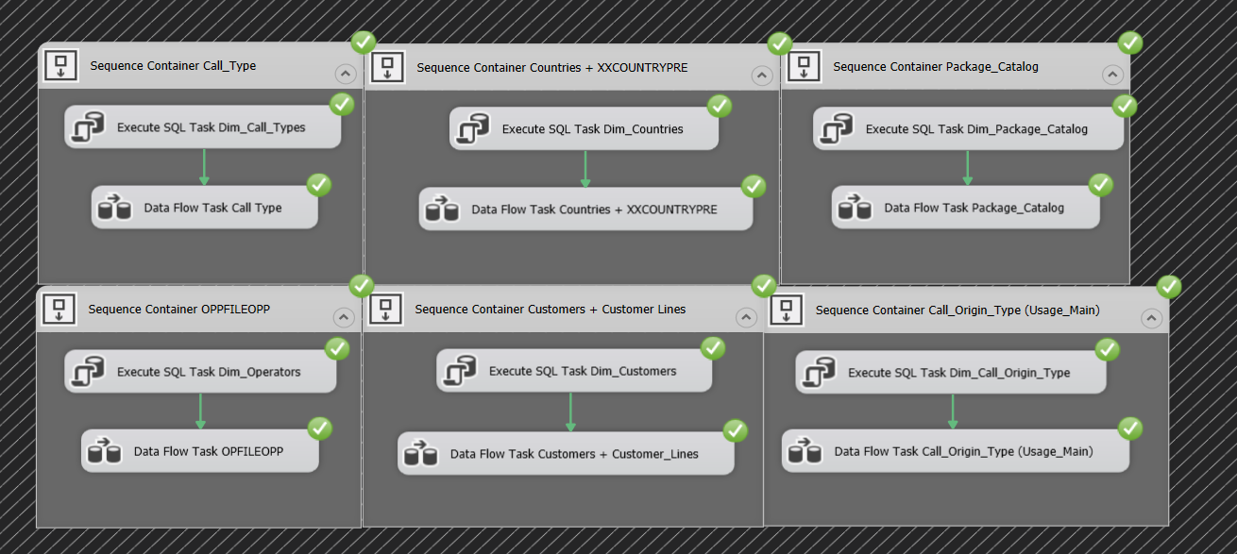Process ETL – Step Stage to DW:

Process ETL - Integration of Countries and Prefix Operators tables with Customers table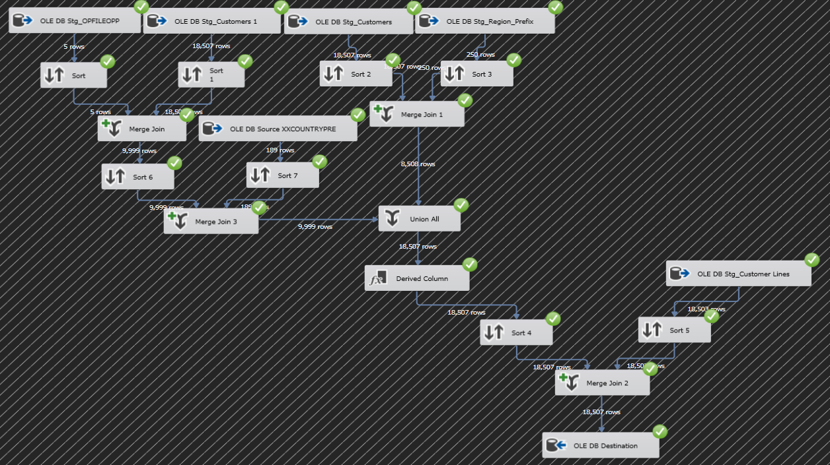:

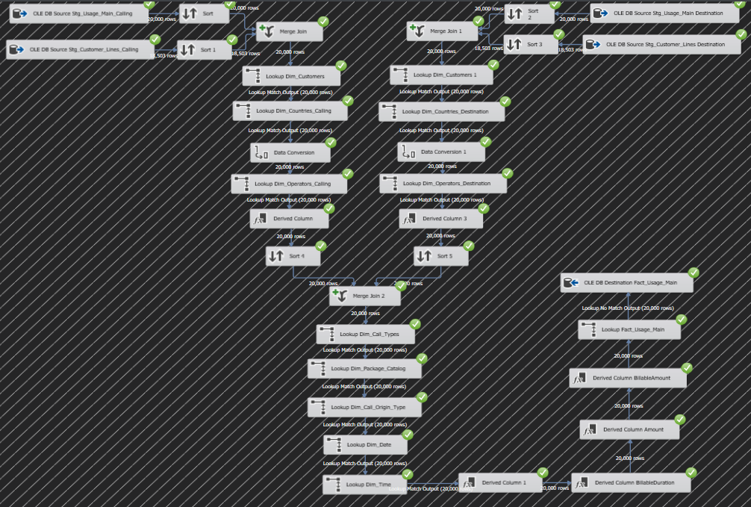Structure and Process ETL in Fact DW: